Princess Sumaya University for Technology
King Abdullah II Faculty of Engineering
Electrical Engineering Department



Embedded Systems Project
Autonomous Robot Car with Line Following, Obstacle Avoidance, and Light Detection

Supervisor: Dr.Belal Sababha
Students: Taha khalaf, Meqdad Rayyan, Hamzeh Awad

Table of Contents
- Abstract
- Introduction and Background
- System Overview
- Mechanical Design
- Electrical / Hardware Design
- Software Design
- Control Algorithm and Operation Stages
- Testing and Results
- Conclusion and Problem Identification

1. Abstract
This project presents the design and implementation of an autonomous robot car based on the PIC16F877A microcontroller. The robot integrates multiple sensors and actuators to achieve intelligent behavior, including line following, obstacle avoidance, and light-based event detection. The system uses infrared sensors for line tracking, an ultrasonic sensor for distance measurement, a light-dependent resistor (LDR) for ambient light detection, DC motors with PWM speed control for motion, and a servo motor for directional scanning. The robot operates in multiple stages, transitioning automatically between behaviors depending on environmental conditions. This project demonstrates the integration of embedded hardware, real-time software control, and sensor-based decision-making in a mobile robotic platform.

2. Introduction and Background
Autonomous mobile robots are widely used in industrial, educational, and research applications due to their ability to interact with the environment without continuous human intervention. Line-following robots represent a fundamental robotics problem that combines sensing, control, and actuation. When enhanced with obstacle avoidance and environmental sensing, such robots become suitable for more realistic and dynamic environments.
The goal of this project is to design a robot car capable of:
- Following a predefined path using infrared line sensors.
- Detecting and avoiding obstacles using an ultrasonic sensor.
- Detecting changes in light intensity using an LDR sensor to trigger different operational stages.
The PIC16F877A microcontroller is used as the central control unit due to its built-in ADC, PWM modules, timers, and sufficient I/O pins for sensor and actuator interfacing.

3. System Overview
The robot car is built around the PIC16F877A microcontroller and consists of the following main subsystems:
- Sensing Subsystem: Infrared line sensors, ultrasonic distance sensor, and LDR light sensor.
- Actuation Subsystem: Two DC motors driven by an H-Bridge motor driver and a servo motor.
- Control Subsystem: Embedded C software implementing timer interrupts, PWM generation, sensor processing, and decision logic.
- Power Subsystem: Battery supply providing power to the microcontroller, sensors, and motors.
The robot operates in multiple stages, starting with line following under normal lighting conditions, then transitioning to obstacle-handling and advanced navigation once specific sensor conditions are met.

4. Mechanical Design
The robot is mounted on a two-wheel drive chassis with the following components:
- Two DC motors attached to the left and right wheels, enabling forward motion, turning, and stopping.
- A free caster wheel at the front or rear to maintain balance.
- A front-mounted ultrasonic sensor for obstacle detection.
- Infrared line sensors mounted underneath the chassis to detect the track.
- A servo motor mounted at the front to support directional sensing or scanning tasks.
All electronic components are fixed onto the chassis using mounting brackets and a base plate, ensuring stability during movement.

5. Electrical / Hardware Design
5.1 PIC16F877A Microcontroller
The PIC16F877A serves as the main controller of the robot. It provides:
- 33 programmable I/O pins
- 10-bit ADC for analog sensors
- CCP modules for PWM generation
- Multiple timers for real-time control
5.2 Sensors
Infrared Line Sensors:
- Two digital IR sensors (left and right) are used for line detection.
- Connected to PORTD pins RD4 (right) and RD5 (left).
- Output LOW when a dark line is detected and HIGH otherwise.
Ultrasonic Sensor (HC-SR04):
- Used for obstacle detection and distance measurement.
- Trigger pin connected to RC4 (output).
- Echo pin connected to RC5 (input).
- Distance is calculated using Timer1 based on echo pulse width.
Light Sensor (LDR):
- Connected to RA0 and read using the ADC module.
- Used to detect changes in ambient light intensity.
5.3 Actuators
DC Motors:
- Two DC motors are controlled via an H-Bridge motor driver.
- Direction pins connected to PORTB (RB4–RB7).
- Speed controlled using PWM signals from CCP1 and CCP2 modules.
Servo Motor:
- Connected to RD0.
- Controlled using a software-generated PWM signal via Timer0 interrupts.
- Servo angle range: 0°–180°.
Buzzer:
- Connected to RD1.
- Activated during light detection events.

6. Software Design
The embedded software is written in Embedded C using MPLAB IDE. The design is modular and consists of the following components:
6.1 Timer and Interrupt Handling
- Timer0 is configured to overflow every 100 µs.
- Used to:
  - Generate servo PWM signals.
  - Implement software-based delays.
6.2 PWM Control
- Hardware PWM (CCP1 and CCP2) is used to control DC motor speed.
- Duty cycle adjustments allow smooth speed variation for turning and obstacle avoidance.
6.3 ADC Module
- ADC is initialized to read the LDR value from RA0.
- Light intensity thresholds are used to trigger stage transitions.
6.4 Sensor Processing
- Line sensor readings determine movement direction.
- Ultrasonic sensor data is converted into distance (cm) for obstacle detection.

7. Control Algorithm and Operation Stages
The robot operates in multiple stages:
Stage 1: Line Following with Light Monitoring
- The robot follows a line using IR sensors.
- Motor speeds are adjusted to maintain alignment.
- LDR continuously monitors ambient light.
- When light intensity drops below a threshold, a buzzer is activated.
- Once light returns to normal, the robot transitions to Stage 2.
Stage 2: Obstacle Handling Initialization
- The robot performs predefined movements (stop, move forward, turn).
- This stage prepares the robot for obstacle-aware navigation.
Stage 3: Obstacle Avoidance and Advanced Navigation
- Ultrasonic sensor continuously measures distance.
- If an obstacle is detected within a critical range, the robot:
  - Stops
  - Moves backward
  - Turns left or right depending on sensor inputs
- When no obstacle is present, the robot resumes forward motion while following the line.
A final condition halts the robot permanently after completing its task sequence.

8. Testing and Results
The robot was tested on a predefined track with obstacles and varying light conditions. Observed results include:
- Stable and accurate line following under normal conditions.
- Reliable detection of obstacles within approximately 20 cm.
- Smooth speed control and turning using PWM.
- Correct stage transitions based on LDR readings.
Minor issues such as sensitivity to ambient lighting and surface reflectivity were observed during testing.

Overview of used components
- A PIC16F877A MICROCONTROLLER

The PIC16F877A is a widely used 8-bit microcontroller from Microchip Technology, known for its simplicity and reliability in embedded system projects. It features 40 pins, including 33 I/O pins, built-in ADC for reading analog sensors, and PWM capabilities for motor control. Its versatility makes it ideal for applications like robotics, automation, and real-time control. In this project, the PIC16F877A acts as the central controller, handling sensor inputs and managing outputs like motors, the water pump, and the servo motor.

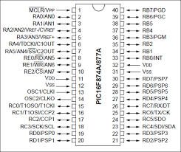

2. Ultrasonic Sensor (HC-SR04)

Used for obstacle detection and distance measurement. It works by emitting an ultrasonic pulse and measuring the time it takes for the echo to return after bouncing off an object. This allows the robot to avoid obstacles while following the black line on the ground.

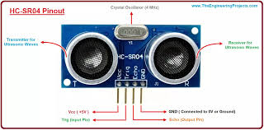
3. H-Bridge

H-Bridge 1: Controls the two DC motors for movement direction and speed.

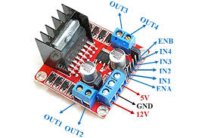
4. Servo Motor
Raises the flag when the car is parked. Controlled by the PIC’s PWM output for precise angular positioning

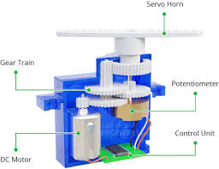

5. IR (Infrared) sensor :
detects infrared radiation (heat/light) to sense objects, motion, or temperature working by either emitting IR light and measuring reflections (active) or detecting naturally emitted heat (passive), commonly used in remote controls, motion detectors, security systems, and robotics for obstacle avoidance and automation.

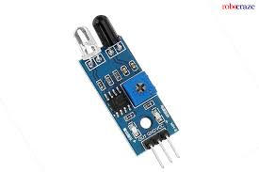

6. Light Sensor (LDR):

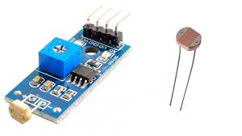
7. Buzzer: makes a buzzing sound when active
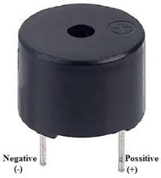
8. 2 dc motors: for moving the car
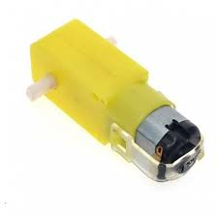

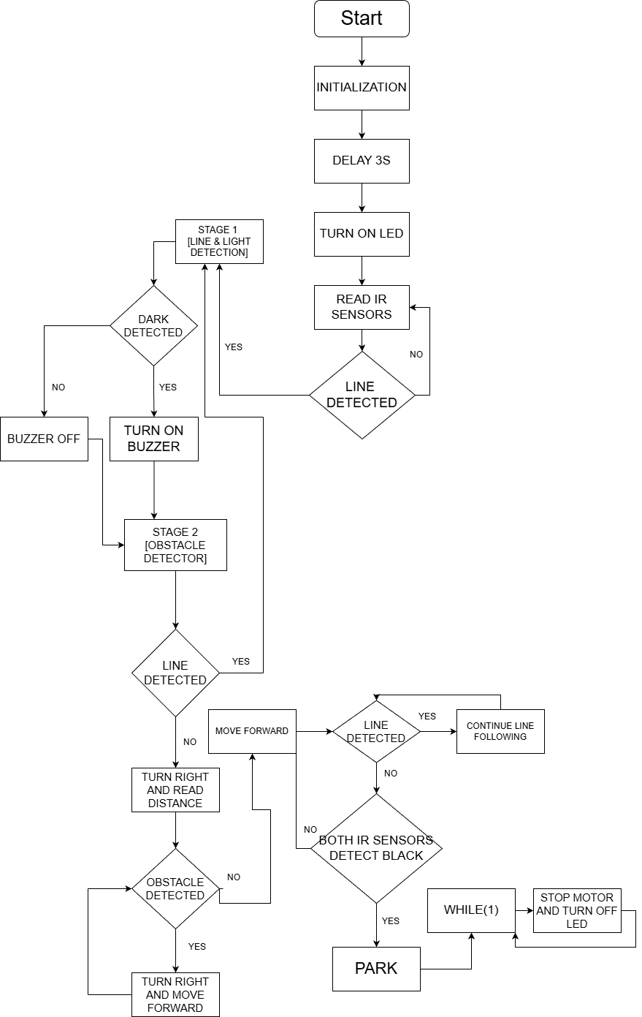
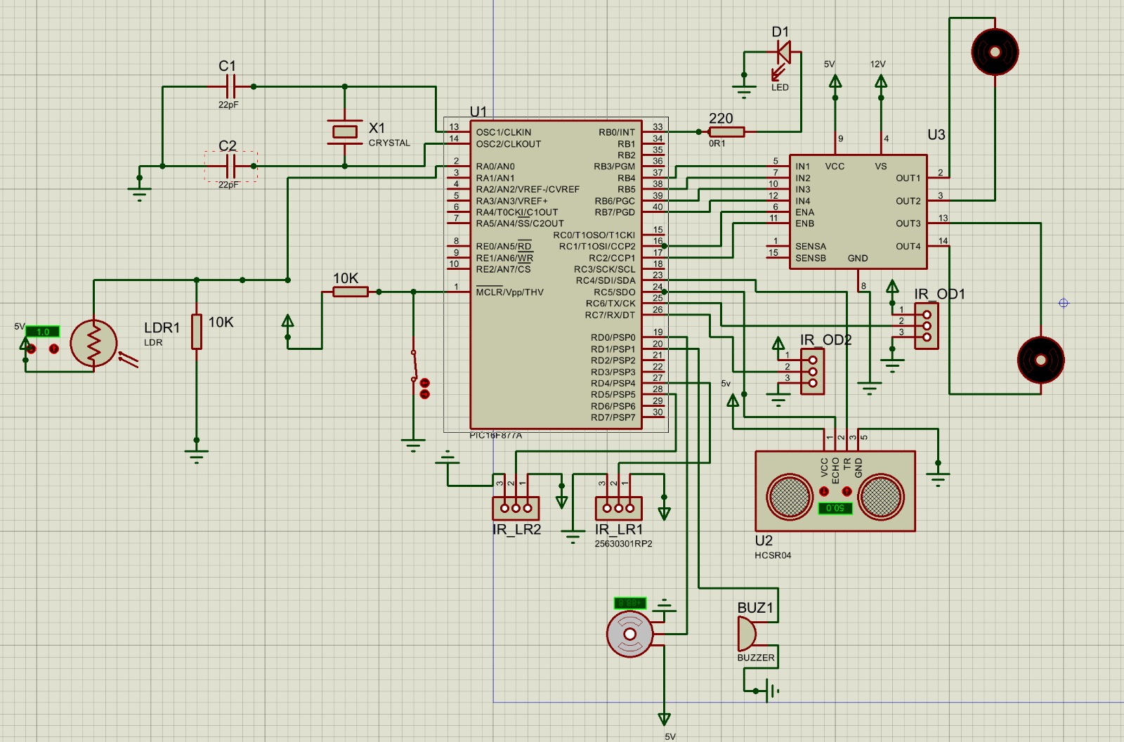

9. Conclusion and Problem Identification
This project successfully demonstrates the design and implementation of an autonomous robot car using the PIC16F877A microcontroller. The robot integrates multiple sensors and actuators to perform line following, obstacle avoidance, and environmental sensing in real time.
Limitations and Future Improvements:
- Sensor Noise: IR and ultrasonic sensors are sensitive to environmental interference.
- Mechanical Stability: Improved chassis design could enhance movement accuracy.
- Power Management: Battery life limits long-duration operation.
- Code Optimization: More advanced control algorithms (e.g., PID control) could improve performance.
- PCB Design: Replacing breadboard connections with a PCB would increase reliability.
Overall, the project provides a strong foundation for more advanced autonomous robotic systems and highlights key concepts in embedded systems and robotics.

